Sounding the Futures: Listening Across Time and Space
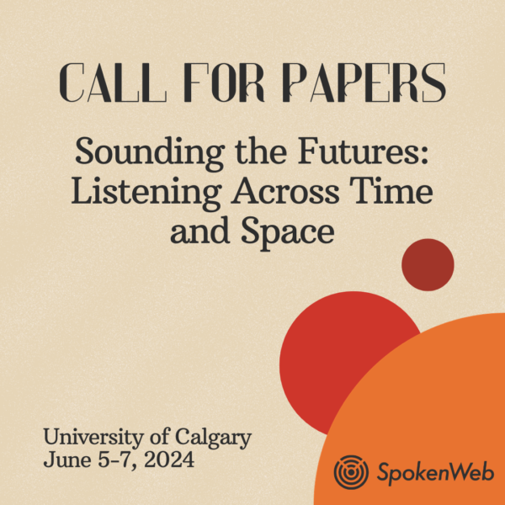
The SpokenWeb research network is pleased to invite you to submit a proposal for our next in-person gathering to be held in Calgary, June 5-7, 2024. This three-day event at the University of Calgary will consist of a Symposium of research papers and presentations and an Institute of workshops and practice-based exchanges. Building on past SpokenWeb events including gatherings held at the University of Alberta, Concordia University, and Simon Fraser University, this event will bring together academics, archivists, librarians, artists, and members of diverse communities interested in literature and sound to exchange ideas, methods, art and knowledge about modes of engaging with the sonic dimensions of literary practice.
As the SpokenWeb Partnership approaches its final years, we invite proposals for papers, panels, workshops, and / or creative performances that engage with questions of futurity. How might we hear the future, including an apocalyptic future which seems to be arriving faster than anticipated? How might listening and creative practices continue to change, and transform the possible futures that may lie ahead of us? How do the temporal dimensions of sound and audition inform our understanding of pastness and futurity? How might a digital archive’s orientation to the future differ from that of an analog archive?
Rather than conceiving orality through a metaphysics of presence harnessed to a particular time and space, queer Oji-Cree writer Joshua Whitehead asserts “orality never asks to be condensed into singularity” but rather “it cascades into infinite registers across time, space, and geographies.” Oral performances of poetries and the recording and dissemination of these performances further expands the infinity of these registers and their potential contexts of audition and effect in the world. If emerging generative AI technologies promise to further disrupt all arts, including literary arts, have we reached a point at which, to quote the title of Davide Balula and Charles Bernstein’s recent book of AI-generated poetry, Poetry Has No Future Unless it Comes to an End?
The SSHRC-funded SpokenWeb partnership aims to develop coordinated and collaborative approaches to literary historical study, digital development, and critical and pedagogical engagement with diverse collections of literary sound recordings from across Canada and beyond. We look backwards and forwards as we engage with both the precarity and potential of time-based media that documents literary practice and performance. How will this field of research interact with a future of increasingly born-digital, AI-generated, or as yet unimagined sounds of poetry?
Potential topics for “Sounding the Futures” events include:
- Sound and non-Western futurities, Including Black and Indigenous futurities
- Archives, oral histories, and posterities
- Artificial Intelligence and sound, listening, performance
- Emerging listening practices
- Speculative genres
- Ecological collapse
- Generative technologies and poetics
- Documenting and archiving emerging creative practices
- Affect and crisis
- Humanities and ChatGPT
- Legacy sounds: sampling and accessing the past
- Analogue revivals
- Sonic artifacts
- Machine listening
- Quantitative Listening
Proposals may take the form of scholarly papers, organized panels, performances, and workshops. In your submission, please specify your preferred mode of delivery and any technical requirements that might exceed the typical.
DEADLINE: Submissions of up to 500 words (or up to 500 words per presenter on panels), accompanied by 100-word biographical notes, should be sent to spokenweb2024@gmail.com by 15 October 2023.
Please note: the Symposium and Institute will be entirely in-person.

